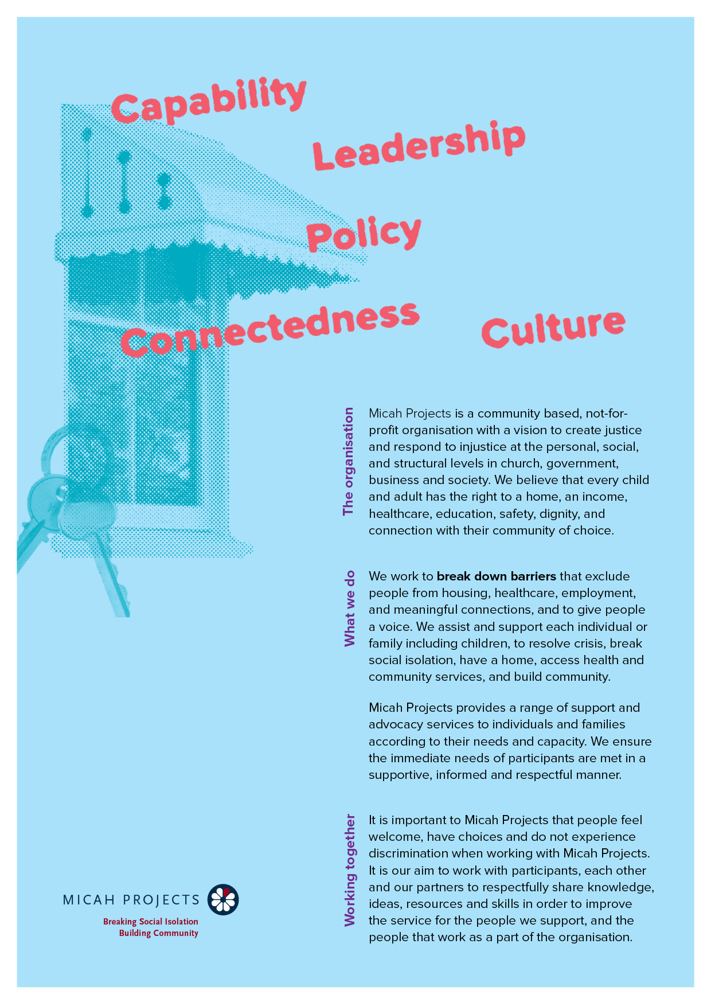
The Hive Social Inclusion
Music Support Volunteer

Equal Opportunity  Micah Projects is an equal opportunity employer and promotes access to positions to individuals from a diverse range of social and cultural groups. We acknowledge the First Peoples of Australia as the traditional owners of this land and support their right to self-determination and cultural expression. We recognise that Brisbane is a diverse community and acknowledge the needs of individuals, families and communities relating to age, gender, disability, sexuality and economic status. | Child Safe Organisation  Children and young people are entitled to live in a caring and nurturing environment and to be protected from harm and exploitation. Micah Projects is a child-safe and child-friendly organisation that prioritises the safety and wellbeing of children and young people. We actively provide guidance for management, staff and others in identifying and responding to concerns about the abuse or neglect of a child or young person in contact with the organisation.
Quality statements  Micah Projects is committed to adhering to well defined, effective procedures that are designed to ensure the quality of our services and activities. We expect staff to understand the relevance and importance of their activities and how they contribute to achieving the quality objectives, and to proactively work and operate within the organisation’s quality system. | WHS Statement  Everyone has a right to feel safe at work, and Micah Projects is committed to minimising the risk to any staff member, student, volunteer, contractor, consultant and Board member within the organisation. We work collectively to comply with the Work Health and Safety Act 2015.

Position Overview

Position Title  Music Group / Open Mic Volunteer | Team  The Hive Social Inclusion
Reports to  Music Facilitator | Line Manages  Community Connections Cluster Lead
Employment Status  Volunteer | Hours of Work  Tuesday (weekly) 12.30 – 3.30pm Tuesday (monthly) 5-8pm
Based at
South Brisbane Q 4101

Micah Projects – The Hive Social Inclusion
About the Program: The Hive is funded by the Queensland Community Support Scheme (QCSS) and we are a social inclusion team. We support individuals with In-Home Supports and Community Connections to maintain or regain their independence so they can continue to live safely in their home and actively participate in their communities.

Position Description

As an Open Mic Volunteer you will…

be supporting the Music Facilitator at a weekly Music Rehearsal group at Brisbane Common Ground, South Brisbane and a monthly Open Mic evening at Hope Street Café, 15 Hope Street South Brisbane. The role would involve supporting the Music Facilitator to:
- Set up of rehearsal / performance space and PA system
- Willing to play and/or sing to support participates where required with own instrument (guitar, ukulele, keyboard, violin, voice etc)
- Create a warm, welcoming and fun social environment
- Open Mic Night, co-host guests in the venue by assisting with offering of pre prepared café refreshments
- Pack down rehearsal / performance space and PA system

Criteria and Conditions

Driver’s License: Preferred but Not Essential | Travel: N/A
Criminal History Screening: Essential Blue Card | Assets: N/A

General Conditions
- All volunteers are to exhibit the values of Micah Projects, as outlined in the Code of Conduct.
- Appointment to this position will be subject to a criminal history check, as outlined in the organisational Criminal History Screening Policy.
- All volunteers will comply with Workplace Health and Safety legislation as outlined in organisational policy and procedures

Click Here to Apply Now

